Lab - Troubleshoot Inter-VLAN Routing

Topology
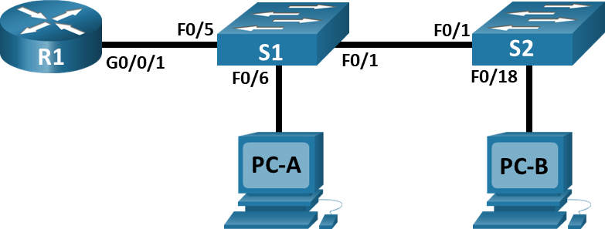

Addressing Table
Device | Interface | IP Address | Subnet Mask | Default Gateway
R1 | G0/0/1.3 | 10.3.0.1 | 255.255.255.0 | N/A
R1 | G0/0/1.4 | 10.4.0.1 | 255.255.255.0 | N/A
R1 | G0/0/1.13 | 10.13.0.1 | 255.255.255.0 | N/A
S1 | VLAN 3 | 10.3.0.11 | 255.255.255.0 | 10.3.0.1
S2 | VLAN 3 | 10.3.0.12 | 255.255.255.0 | 10.3.0.1
PC-A | NIC | 10.4.0.50 | 255.255.255.0 | 10.4.0.1
PC-B | NIC | 10.13.0.50 | 255.255.255.0 | 10.13.0.1

VLAN Table
VLAN | Name | Interface Assigned
3 | Management | S1: VLAN 3  S2: VLAN 3
4 | Operations | S1: F0/6
7 | ParkingLot | S1: F0/2-4, F0/7-24, G0/1-2  S2: F0/2-17, F0/19-24, G0/1-2
8 | Native | N/A
13 | Maintenance | S2: F0/18

Objectives
Part 1: Evaluate Network Operation
Part 2: Gather information, create an action plan, and implement corrections

Background / Scenario
Your instructor has preconfigured all the network equipment and has included intentional errors that are keeping the inter-VLAN routing from working. Your task is to evaluate the network and identify and correct the configuration errors to restore full connectivity. You may find errors with the configurations which are not directly related to inter-VLAN routing that impact the ability of the network devices to perform this function.
Note: The design approach used in this lab is to assess your ability to configure and troubleshoot inter-VLAN routing only. This design may not reflect networking best practices.
Note: The router used with CCNA hands-on labs it the Cisco 4221 with Cisco IOS XE Release 16.9.4 (universalk9 image). The switches used in the labs are Cisco Catalyst 2960s with Cisco IOS Release 15.2(2) (lanbasek9 image). Other routers, switches, and Cisco IOS versions can be used. Depending on the model and Cisco IOS version, the commands available and the output produced might vary from what is shown in the labs. Refer to the Router Interface Summary Table at the end of the lab for the correct interface identifiers.
Note: Ensure that the routers and switches have been erased and have no startup configurations. If you are unsure contact your instructor.

Required Resources
- 1 Router (Cisco 4221 with Cisco IOS XE Release 16.9.4 universal image or comparable)
- 2 Switches (Cisco 2960 with Cisco IOS Release 15.2(2) lanbasek9 image or comparable)
- 2 PCs (Windows with a terminal emulation program, such as Tera Term)
- Console cables to configure the Cisco IOS devices via the console ports
- Ethernet cables as shown in the topology

Instructions

Evaluate Network Operation.
Note: You may need to disable the Windows Firewall on PC–A and PC–B.
Requirement:
- No VLAN 7 trunk traffic because there is no devices in VLAN 7.
- VLAN 8 is the native VLAN.
- All trunks are static.
- End to end connectivity

Use Ping to test the following criteria and record the results in the table below.
From | To | Ping Results
R1 | S1 VLAN 3 (10.3.0.11) | Ping Fail
R1 | S2 VLAN 3 (10.3.0.12) | Ping Fail
R1 | PC-A (10.4.0.50) | Ping Fail
R1 | PC-B (10.13.0.50) | Ping Fail
S1 | S2 VLAN 3 (10.3.0.12) | Ping Fail
S1 | PC-A (10.4.0.50) | Ping Fail
S1 | PC-B (10.13.0.50) | Ping Fail
S2 | PC-A (10.4.0.50) | Ping Fail
S2 | PC-B (10.13.0.50) | Ping Fail

Gather information, create an action plan, and implement corrections.
      - For each criterion that is not met, gather information by examining the running configuration and routing tables and develop a hypothesis for what is causing the malfunction.
      - Create an action plan that you think will fix the issue. Develop a list of all the commands you intend to issue to fix the issue, and a list of all the commands you need to revert the configuration, should your action plan fail to correct the issue.
Hint: If you need to reset a switchport to default configuration, use the command default interface interface name.
As an example for F0/10:
S1(config)# default interface f0/10
      - Execute your action plans one at a time for each criterion that fails and record the fix actions.

Device | Interface | Problem | Solution
S1 | FA0/1 | 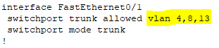  Missing native vlan 8  Allowed vlan missing vlan 3 | 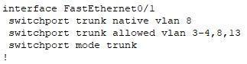  S1(config)#int f0/1  S1(config-if)#switchport trunk native vlan 8  S1(config-if)#switchport trunk allowed vlan add 3
S2 | FA0/1 | 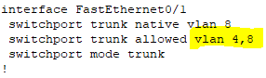  Allowed vlan missing vlan 3 and 13 | 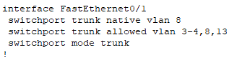  S2(config)#int f0/1  S2(config-if)#switchport trunk allowed vlan add 3  S2(config-if)#switchport trunk allowed vlan add 13
S1 | Vlan 3 | 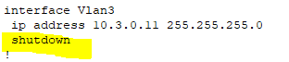  Int vlan 3 is shutdown | 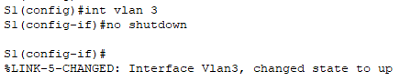  S1(config)#int vlan 3  S1(config-if)#no shutdown
S2 | Vlan 3 | 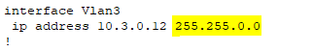  Subnet mask for vlan 3 is wrong. | 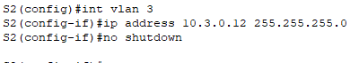  S2(config)#int vlan 3  S2(config-if)#ip address 10.3.0.12 255.255.255.0  S2(config-if)#no shutdown
S2 | F0/18 | 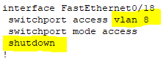  Wrong Vlan Membership and shutdown | 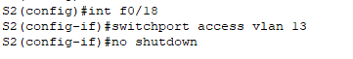  S2(config)#int f0/18  S2(config-if)#switchport access vlan 13  S2(config-if)#no shutdown
S1 |  | 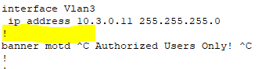  Missing default gateway | S1(config)#ip default-gateway 10.3.0.1
S2 |  | 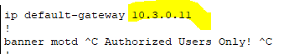  Default gateway wrong ip address | S2(config)#ip default-gateway 10.3.0.1
PC-A |  | 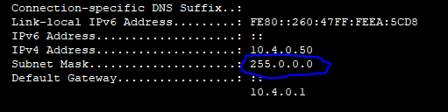  Subnet Mask Wrong | 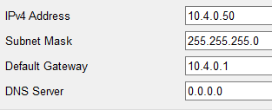  Subnet Mask : 255.255.255.0
PC-B |  | 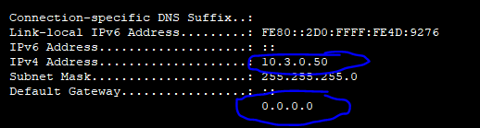  IPv4 address is wrong  Default gateway is wrong | 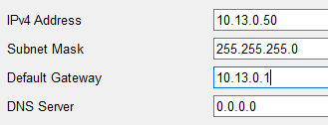  IP Address : 10.13.0.50  Default Gateway : 10.13.0.1
S1 | F0/5 | 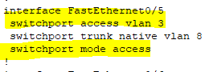  The Interface F0/5 must be trunk and trunk native vlan 8.So mode access and vlan 3 is wrong. | 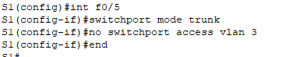  S1(config)#int f0/5  S1(config-if)#switchport mode trunk  S1(config-if)#no switchport access vlan 3  S1(config-if)#end  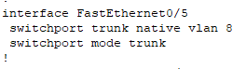
S1 |  | 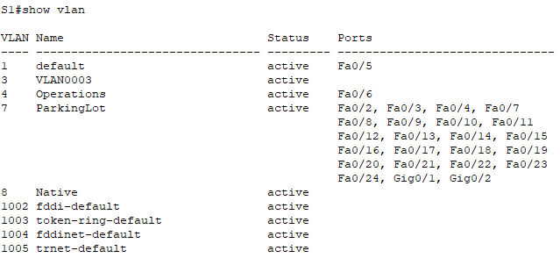  Vlan 13 is missing | 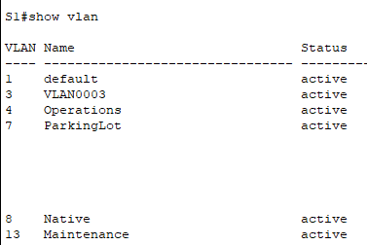  S1(config)#vlan 13  S1(config-vlan)#name Maintenance
R1 | G0/0/1 | 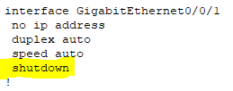  The interface G0/0/1 should be not shutdown | 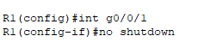  R1(config)#int g0/0/1  R1(config-if)#no shutdown
R1 | G0/0/1.3 | 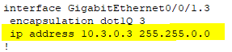  The sub-interface G0/0/1.3 is assign wrong ip address and subnet mask. | 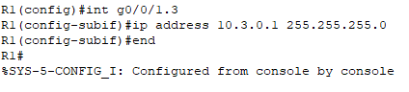  R1(config)#int g0/0/1.3  R1(config-subif)#ip address 10.3.0.1 255.255.255.0
R1 | G0/0/1.4 | 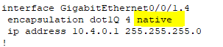  The encapsulation should not be have native | 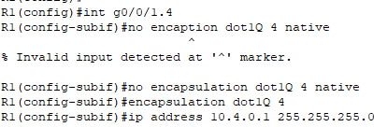R1(config)#int g0/0/1.4  R1(config-subif)#no encapsulation dot1Q 4 native  R1(config-subif)#encapsulation dot1Q 4  R1(config-subif)#ip address 10.4.0.1 255.255.255.0
R1 | G0/0/1.8 | 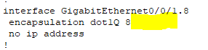  The encapsulation should be have native | 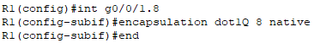  R1(config)#int g0/0/1.8  R1(config-subif)#encapsulation dot1Q 8 native
R1 | G0/0/1.13 | 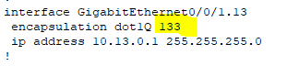  The encapsulation is wrong | 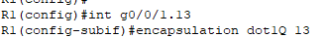  R1(config)#int g0/0/1.13  R1(config-subif)#encapsulation dot1Q 13
End of document

